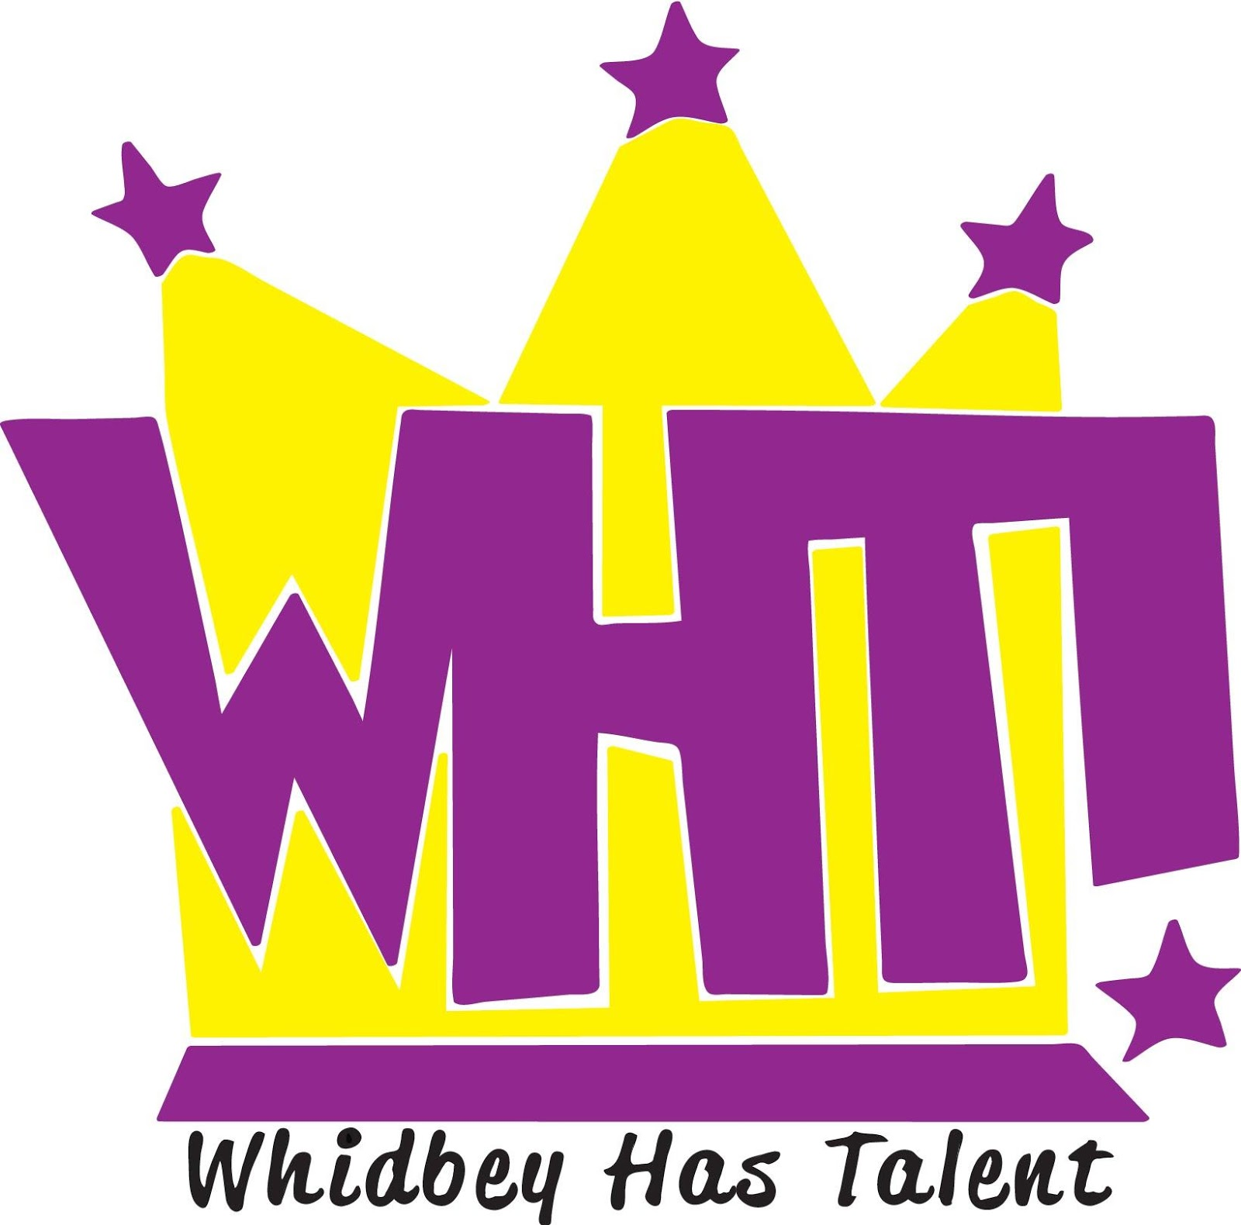
AUDITION FEE
AUDITION NUMBER

AUDITION APPLICATION

STUDENT NAME AGE GRADE

OTHER ACT MEMBERS (IF ANY) Each student in the act must submit a parent signed entry form.

MAILING ADDRESS

PARENT EMAIL PHONE

STUDENT EMAIL PHONE

SCHOOL NAME

Write or check the name that best describes your Act: (Check/Circle as applicable)
- BAND
- INSTRUMENTAL SOLO DUO TRIO ENSEMBLE
- VOCAL SOLO DUO TRIO ENSEMBLE
- DANCE SOLO DUO TRIO GYMNASTIC ROUTINE
- MONOLOGUE POEM ORAL INTERPRETATION
- MAGIC
- OTHER (describe)__________________________________________________________________________

Song Title/Composer Name/Lyricist Name/Recording Artist

_________________________________________________________________________________
*If your act will have an accompanist, please give his/her name and phone number:
Accompanist Name: | Accompanist Phone:
Check the equipment you will need WHT to provide for your act.
- MUSIC STAND
- PIANO & PIANO BENCH
- MP3 PLAYER
- CHAIR/STOOL
- OTHER

LIABILITY RELEASE CONSENT

The signature below indicates that I ______________________ & ______________________have read and accept the participation rules for Whidbey Has Talent. Participant(s) agree to hold harmless the Whidbey Playhouse Inc. and its Officers/members and agents for all claims of liability, loss or damage the participant or others may suffer arising as a result of their participation in Whidbey Has Talent, including losses arising out of the negligent acts or omissions of the Whidbey Playhouse, its officers/members and agents.

___________________________________ _________________________________________
Print name of Student Applicant Signature of Student Applicant Date

___________________________________ __________________________________________
Print name of parent/legal guardian Signature of parent/legal guardian Date

PHOTOGRAPH AND PUBLICITY RELEASE CONSENT

I, ________________________, give the Whidbey Has Talent Program and its fiscal agent, the Whidbey Playhouse, permission to use my name, likeness, image, voice, and/or appearance as such may be embodied in any pictures, photos, video recordings, audiotapes, digital images, and the like, taken or made on behalf of the Whidbey Has Talent Program or Whidbey Playhouse activities. I agree that the Whidbey Has Talent Program and the Whidbey Playhouse have complete ownership of such pictures, etc., including the entire copyright, and may use them for any purpose consistent with the Whidbey Playhouse mission. These uses include, but are not limited to illustrations, bulletins, exhibitions, videotapes, reprints, reproductions, publications, advertisements, and any promotional or educational materials in any medium now known or later developed, including the Internet. I acknowledge that I will not receive any compensation, etc. for the use of such pictures, etc., and hereby release the Whidbey Has Talent and its agents and assigns from any and all claims which arise out of or are in any way connected with such use. Applicants who do not agree to consent as outlined above will not be allowed to participate in Whidbey Has Talent, either as an individual or as part of an act or as an accompanist.

I have read and understand this consent and release.

I give my consent to Whidbey Playhouse to use my name and likeness to promote the Whidbey Has Talent program, its fiscal agent, and/or their activities.

Print name of parent/legal guardian Date Print Name of Student Applicant

Signature of parent / legal guardian Date Signature of Student Applicant

Participant Rules
Whidbey Has Talent is limited to public, private or homeschool students in grades K-12 who reside in the school districts of Whidbey Island, WA.
- No student may participate in more than one act. The Whidbey Has Talent committee may exclude any act that the committee determines to be inappropriate for a community youth talent show. Additional student accompanists must share the prize.
- Lip-sync acts and acts with open flame will not be allowed.
- Profanity and inappropriate suggestive song lyrics will not be allowed.
- Come to audition prepared to perform your act.
  - If applicable bring:
- mp3 or CD track (if needed)
- Musical instrument(s) necessary for the act (A digital piano may be available upon request.)
- Props
- Wearing show attire or costume is optional for the audition
- Audition Entry forms along with an audition fee of $10 are due AT THE TIME OF YOUR AUDITION, OR can be filled out beforehand and brought to the office.
- Participants are encouraged to memorize their act. No special lighting will be provided.
- A MANDATORY FULL DRESS rehearsal will be held on Saturday, April 4, 2020 from 10:00 a.m. to 4:00 p.m. by assignment in the Whidbey Playhouse Main Stage.
- Whidbey Has Talent will showcase acts by division on Sunday, April 5, 2020 -2:00 pm (Presentation Division)
4:00 pm (Junior Division) & 6:30 pm (Senior Division), at the Whidbey Playhouse Main Stage. Show participants
will be grouped into three divisions. Participants of each division level will compete for awards to be used
to enhance study and knowledge in their field. Division Acts involving more than one participant will share the award. A panel of judges will determine the winners of each division. Special awards will be given at the
discretion of the committee, or with the desire of the donor of the special award.
- Presentation Division acts will not exceed four (4) minutes. Junior and Senior acts should be planned to last about five (5) minutes. Any act that exceeds six (6) minutes will be disqualified.
- Any student from a lower division, who appears with a student of a higher division, competes at the higher division.
- Students, who win first prize in their division, may perform in future years in the same division, however, they are not eligible for the first-place award prize but may qualify for a special award.
- *Contestants will be eligible to receive coaching tips at a mentor session on March 21, 2020.
- *Contestants will be eligible to showcase their act at a preview performance March 14, 2020.
- *Place winners will be eligible to showcase their act at encore performances.

DATES AT A GLANCE

K-12 Audition Dates

Monday, February 10, 2020 OPEN AUDITION (5:00 - 8:00 p.m.)
@ Whidbey Playhouse Lobby & Main Stage -730 SE Midway Blvd. Oak Harbor, WA
Tuesday, February 11, 2020 OPEN AUDITION (5:00 - 8:00 p.m.)
@ Whidbey Playhouse Lobby & Main Stage -730 SE Midway Blvd. Oak Harbor, WA

Wednesday, February 12, 2020 OPEN AUDITION (2:30 – 5:00 p.m.)
@ Oak Harbor High School Choir Room – #1 Wildcat Way. Oak Harbor, WA
[For OHHS Students ONLY]
Thursday, February 13, 2020 OPEN AUDITION (2:30-5:00 p.m.)
@ Oak Harbor High School Choir Room - #1 Wildcat Way Oak Harbor, WA
[For OHHS Students ONLY]

Sneak Preview Date
Saturday, March 14 2020 (10:30 am & 3:30 pm) @ Regency 1040 S.W. Kimball Dr. Oak Harbor, WA

Coaching Date
Saturday, March 21, 2020 (9:00 am - 4:00 pm) by appointment @ Whidbey Playhouse Star Studio

MANDATORY Dress Rehearsal Date
Saturday, April 4, 2020 by assignment @ Whidbey Playhouse Main Stage

Whidbey Has Talent Production Date
Sunday, April 5, 2020 @ Whidbey Playhouse Main Stage
2:00 Presentation Level [K-5th Grade]
4:00 Junior Level [6th-8th Grade]
6:30 Senior Level [9th-12th Grade]
Whidbey Playhouse Main Stage -730 SE Midway Blvd. Oak Harbor

